Business Requirements Document
Data Warehouse Data Retention and Archiving using Azure Data Factory
Attribute | Value
Document ID | BRD-DWH-RET
Version | 1.1
Status | Draft for Review
Date | 10 November 2026
Prepared by | Agus Laksono
Approval status | Waiting for approval

Document Control

Revision History
Version | Date | Author | Description
1.0 | 2 November 2026 | Agus Laksono | Initial draft.
1.1 | 10 November 2026 | Agus Laksono | - Log retention of 3 years  - Error code table with user actions  - Decided archive layout

Approval
Role | Name | Signature | Date | Decision
Business / Data Owner | Rishandi
Project Owner | Rishandi

Document Conventions
Item | Meaning
OBJ-nn | Business objective
IS-nn / OS-nn | In-scope item / out-of-scope item
IC-nn / DR-nn | Process step of the Initial Cut-off Run / Daily Routine
BR-nn | Business rule
BRQ-nn | Business requirement
NFR-nn | Non-functional requirement
A-nn / C-nn / D-nn | Assumption / constraint
R-nn | Risk
AC-nn / SC-nn | Acceptance criterion / success criterion
Table of Contents
Document Control 2
Revision History 2
Approval 2
Document Conventions 2
1. Introduction 7
1.1 Purpose 7
1.2 Background 7
1.3 Business Objectives 7
1.4 Terms and Abbreviations 7
2. Scope 7
2.1 In Scope 7
2.2 Out of Scope 8
3. Stakeholders 8
4. Current State and Future State 9
4.1 Current State 9
4.2 Future State 9
4.3 Data Lifecycle 9
4.4 System Context 10
4.5 High-Level Data Flow 11
5. Business Processes 12
5.1 Table Onboarding 12
5.2 Initial Cut-off Run 13
5.3 Daily Routine 15
6. Business Rules 16
7. Business Requirements 17
7.1 Functional Requirements 17
7.2 Non-Functional Requirements 18
7.3 Configuration Table 18
7.4 Execution Log 19
8. Assumptions, Constraints and Dependencies 20
8.1 Assumptions 20
8.2 Constraints 20
9. Risks 21
10. Acceptance and Success Criteria 22
10.1 Acceptance Criteria 22
10.2 Success Criteria 23

List of Figures
Figure 1 – System context 10
Figure 2 – High-level data flow 11
Figure 3 – Business process flow – Initial Cut-off Run 13
Figure 4 – Business process flow – Daily Routine 15

List of Tables
Table 1 – Business objectives 7
Table 2 – In-scope items 8
Table 3 – Out-of-scope items 8
Table 4 – Stakeholder roles and responsibilities 8
Table 5 – Data lifecycle segments 9
Table 6 – Initial Cut-off Run steps 14
Table 7 – Daily Routine steps 16
Table 8 – Business rules 17
Table 9 – Functional requirements 18
Table 10 – Non-functional requirements 18
Table 11 – Configuration table attributes 19
Table 12 – Assumptions 20
Table 13 – Constraints 20
Table 15 – Risks 21
Table 16 – Acceptance criteria 23
Table 17 – Success criteria 23

Glossary
Abbreviations
Abbreviation | Meaning
ADF | Azure Data Factory, the service that orchestrates the retention process.
BRD | Business Requirements Document.
DBA | Database Administrator.
DWH | Data Warehouse: the database on Azure SQL Database that is subject to retention.
ETL | Extract, Transform and Load: the processes that load data into the DWH.
FSD | Functional Specification Document.
UTC | Coordinated Universal Time. All dates in this document are evaluated in UTC+7.
SLA | Service Level Agreement.
Terms
Term | Definition
Active flag | Configuration attribute that indicates whether a table is processed.
Agreed baseline | The reference ETL execution time and report response time agreed with the Customer, against which the impact of the retention process is measured.
Archive | Parquet files in Azure Blob Storage that hold data more than three and up to eight years old.
Archive cut-off date | Run date minus the total retention period (default eight years). Data and archive files with a business date before this date are removed.
Archive retention period | The number of years data is kept as Parquet files in Azure Blob Storage after it has left the DWH. Default: five years.
Archived segment | Data with a business date on or after the archive cut-off date and before the DWH cut-off date. It is exported to Parquet and then deleted from the DWH.
Azure Blob Storage | Azure storage service that holds the Parquet archive files.
Azure SQL Database | The Azure managed database service that hosts the DWH database, including schema ret.
Batch delete | Deleting eligible rows in repeated batches of a limited number of rows, with a short pause between batches.
Business date | The date on which the business event occurred, for example dtmDate. Retention is measured against this date.
Child table | A table without its own business date column; its rows take the business date of a related header table row.
Configuration table | Central table that defines, for each table, the settings used by the retention process.
Daily Routine | The scheduled daily process that archives and removes data as it ages beyond the cut-off dates. It starts on the day after the Initial Cut-off Run has been completed for all in-scope tables of the initial implementation. A table added later is included from the day after its own Initial Cut-off Run is completed.
DWH cut-off date | Run date minus the DWH retention period (default three years). Data with a business date before this date leaves the DWH.
Execution log | Records written to the log tables for each table and execution.
Expired segment | Data with a business date before the archive cut-off date.
Hypercare | The period of support after deployment, until 31 March 2027 (date under confirmation).
Initial Cut-off Run | Initial implementation (cut-off): the process, executed once for each in-scope table, that archives historical data and removes data beyond the retention period. It is executed for all in-scope tables during the initial implementation, and for each table added to the configuration table later, before that table enters the Daily Routine.
Initial Cut-off status | Status of each table kept by the solution: pending, running, failed, stopped or completed.
Integration Runtime | The ADF component that provides connectivity between ADF and the data stores. It is provided by the Customer infrastructure team.
Log retention period | The number of years the log records of a table are kept in the DWH. Default: three years.
Parquet | Columnar file format used for the archive files.
Retained segment | Data with a business date on or after the DWH cut-off date. It stays in the DWH.
Retention column | The business date column of a table, registered in the configuration table. It must be of type date, datetime, datetime2 or smalldatetime and must not contain NULL values.
Retention period | The number of years data is kept: the DWH retention period (default three years) and the archive retention period (default five years). The total retention period is their sum (default eight years).
Rolling window | A retention window that is recalculated relative to the run date on every daily run.
Row-count validation | Comparison of the number of rows in the Parquet files with the number of rows in the DWH for the same data, performed before any data is removed from the DWH.
Run date | The calendar date in UTC+7 when a run starts. It stays the same for the whole run, also when the run continues after midnight.
Schema ret | The database schema in the DWH database that holds the configuration table, log tables, and stored procedures of the retention solution.
Size category | Small, medium or large, assigned per table in the technical assessment. It sets the default Initial Cut-off Run method.
Stored procedure | A program stored in the DWH database under schema ret that implements part of the retention logic.
Table rebuild | Replacing a large table by a new table that contains only the retained data. Used only in the Initial Cut-off Run.
Technical assessment | The assessment that determines the table size limits (small, medium, large) and any exceptions to the default Initial Cut-off Run method.

1. Introduction

1.1 Purpose
This document defines the business requirements for an automated, configuration-driven data retention and archiving process for the Data Warehouse (DWH). Once approved, it is the baseline for the Functional Specification Document (FSD), development, and user acceptance testing.

1.2 Background
The DWH runs on Azure SQL Database and keeps all history: 421 tables, about 825 GB. 102 tables hold dated transactional history (about 777 GB) that keeps growing. The Customer requires an automated mechanism that keeps the most recent three years of data in the DWH, keeps the following five years as Parquet files in Azure Blob Storage, and removes data older than eight years. The process is orchestrated by Azure Data Factory (ADF) and controlled through a central configuration table, so that multiple tables can be managed without code changes.

1.3 Business Objectives
ID | Objective
OBJ-01 | Keep only the most recent three years of data in the DWH, based on the business date.
OBJ-02 | Keep data that is more than three and up to eight years old as Parquet files in Azure Blob Storage.
OBJ-03 | Run retention and archiving automatically every day.
OBJ-04 | Manage retention for multiple tables through configuration rather than code.
OBJ-05 | Delete data in a way that minimises impact on ETL and reporting workloads.
OBJ-06 | Record every execution in log tables for operational follow-up.
Table 1 – Business objectives

1.4 Terms and Abbreviations
Terms and abbreviations used in this document are defined in the Glossary at the beginning of this document.

2. Scope

2.1 In Scope
ID | Item
IS-01 | Review and analysis of business and technical requirements.
IS-02 | Identification of in-scope DWH tables and their business date columns.
IS-03 | Configuration-driven approach supporting multiple tables.
IS-04 | Data retention logic in the DWH, implemented through stored procedures and scripts in schema ret of the DWH database.
IS-05 | Archiving of eligible DWH data as Parquet files in Azure Blob Storage.
IS-06 | Deletion of archived Parquet files older than the total retention period.
IS-07 | Batch deletion mechanism, and table rebuild for the Initial Cut-off Run.
IS-08 | Initial Cut-off Run and Daily Routine as separate processes.
IS-09 | ADF pipelines for automated daily execution.
IS-10 | Execution logging and log-based monitoring.
IS-11 | Documentation covering design, configuration, setup, and operational guidance.
IS-12 | Knowledge transfer to the operations team.
IS-13 | Hypercare support after deployment until 31 March 2027 (date under confirmation).
IS-14 | Retention of execution log records for a configurable number of years (default three).
Table 2 – In-scope items

2.2 Out of Scope
ID | Item
OS-01 | Any archive platform other than Parquet files in Azure Blob Storage (for example, data lake or SharePoint).
OS-02 | Changes to source systems.
OS-03 | Major schema redesign of DWH tables.
OS-04 | Changes to reports or dashboards.
OS-05 | Network and infrastructure, including connectivity, Integration Runtime, database service, and storage account provisioning.
OS-06 | Automated alerts and notifications (for example, email or Microsoft Teams), performance reporting, and monitoring integration. Any such requirement is subject to separate assessment and approval.
OS-07 | Removal of deleted data from database backups.
OS-08 | Development or modification of dedicated performance reports, dashboards, or additional monitoring interfaces, unless explicitly agreed by the relevant stakeholders.
OS-09 | Retention of child tables that have no business date column of their own (32 tables) and of their header tables in go-live phase 1.
Table 3 – Out-of-scope items

3. Stakeholders
Names are recorded for the roles confirmed to date. Other names will be added when available.
Role | Name | Responsibilities
Business / Data Owner | Rishandi | Approves retention periods and this document. Confirms the in-scope tables and business date columns, which Customer users enter in the configuration table. Agrees the Daily Routine execution time. Signs off user acceptance testing.
Project Owner | Rishandi | Approves scope and this document.
Infrastructure Team |  | Provides network connectivity, Integration Runtime, and the archive storage account and container.
Operations / Support Team |  | Reviews execution logs daily and receives knowledge transfer.
Table 4 – Stakeholder roles and responsibilities

4. Current State and Future State

4.1 Current State
- The DWH runs on Azure SQL Database; server time is UTC.
- Daily database backups are scheduled.
- No in-scope table is partitioned.
- There is no retention or archiving; all history is kept in the DWH.

4.2 Future State
- The DWH holds only data with a business date on or after the DWH cut-off date.
- Data with a business date from the archive cut-off date up to the day before the DWH cut-off date is held as Parquet files in Azure Blob Storage, one file per table and business date.
- Data with a business date before the archive cut-off date is removed from the DWH and from Azure Blob Storage.
- A central configuration table defines which tables are processed and how. The configuration table, log tables, and stored procedures reside in the DWH database under schema ret.
- The Initial Cut-off Run is executed once for each in-scope table. The Daily Routine starts on the day after the Initial Cut-off Run has been completed for all in-scope tables of the initial implementation. A table added later goes through its own Initial Cut-off Run before it enters the Daily Routine.
- Every execution is recorded in log tables, which keep the records of the last three years.

4.3 Data Lifecycle
Example for run date 27 October 2026 with the default retention periods: DWH cut-off date = 27 October 2023; archive cut-off date = 27 October 2018.
Segment | Business date | Treatment | Example
Retained in DWH | On or after the DWH cut-off date | Kept in the DWH | 27 Oct 2023 onwards
Archived | On or after the archive cut-off date and before the DWH cut-off date | Exported to Parquet, validated, then deleted from the DWH | 27 Oct 2018 to 26 Oct 2023
Expired | Before the archive cut-off date | Initial Cut-off Run: deleted from the DWH without archiving.  Daily Routine: Parquet files deleted from Azure Blob Storage. | Before 27 Oct 2018
Table 5 – Data lifecycle segments

4.4 System Context
The solution involves three platform components. Azure Data Factory orchestrates the process. The DWH database on Azure SQL Database holds both the DWH tables and, under schema ret, the configuration table, log tables, and stored procedures of the retention solution. ADF reads the configuration and eligible data from the DWH database, writes Parquet files to Azure Blob Storage, invokes the stored procedures that remove data from the DWH tables, and writes execution logs to the log tables. Network connectivity and the Integration Runtime are provided by the Customer infrastructure team and are outside the project scope.
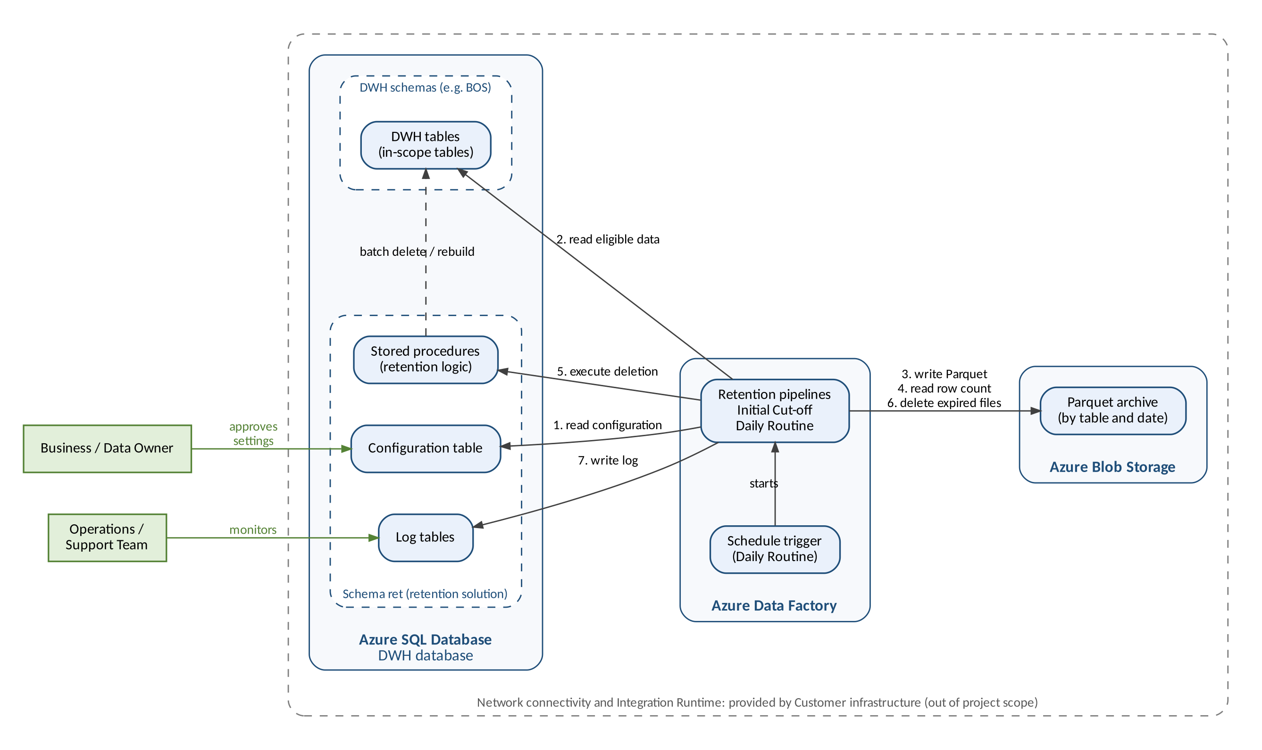
Figure 1 – System context

4.5 High-Level Data Flow
Each row of an in-scope table is classified by its business date. Retained data stays in the DWH. Archive-segment data is exported to Parquet and validated by row count. Data is removed from the DWH only when validation succeeds; otherwise, nothing is deleted and the failure is recorded. Expired data is removed without archiving during the Initial Cut-off Run only, and expired Parquet files are deleted by the Daily Routine.
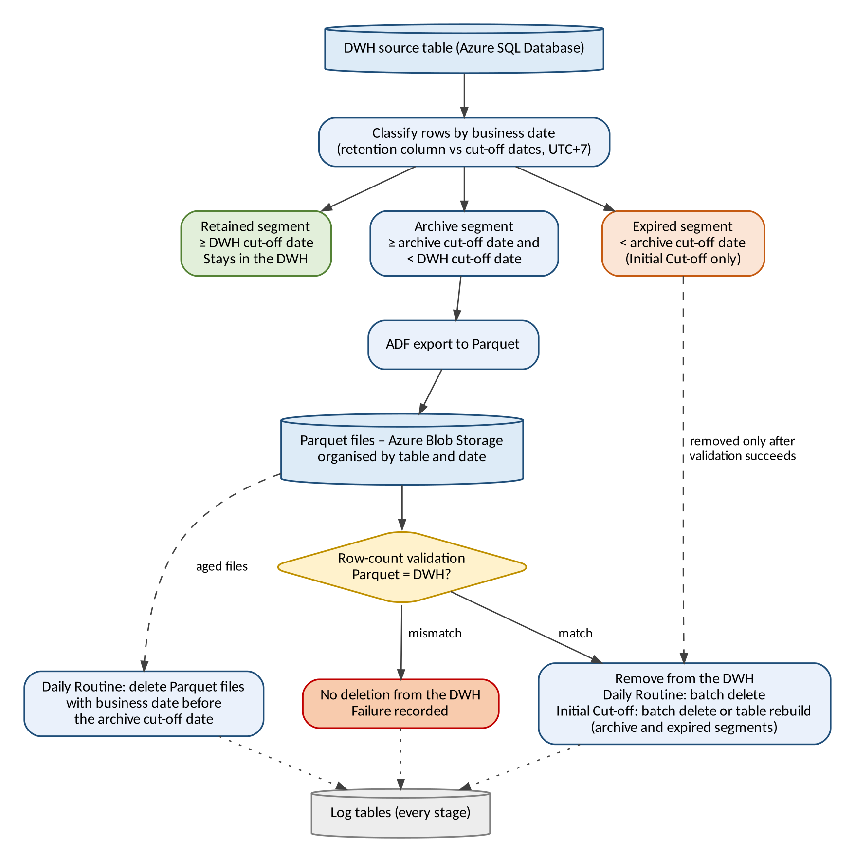
Figure 2 – High-level data flow

5. Business Processes

5.1 Table Onboarding
- Analyse DWH tables to identify the in-scope tables and their business date columns.
- Determine the size category of each table (small, medium or large) in the technical assessment. This sets the Initial Cut-off Run method: batch delete for small and medium tables, table rebuild for large tables.
- Customer users enter each in-scope table, its business date column, size category and Initial Cut-off Run method in the configuration table.
- Execute the Initial Cut-off Run: small and medium tables first, then large tables once the downtime has been determined.
- After the Initial Cut-off Run has been completed for all in-scope tables, the Daily Routine starts on the following day.
- A table added later goes through steps 2 to 4 and enters the Daily Routine from the day after its own Initial Cut-off Run is completed.

The Initial Cut-off Run and the Daily Routine are separate processes and are shown in separate diagrams.

5.2 Initial Cut-off Run
The Initial Cut-off Run is started manually for each table within 09:00 PM to 05:00 AM (UTC+7). No data is removed before the archive has been validated. Data older than eight years is removed without archiving.
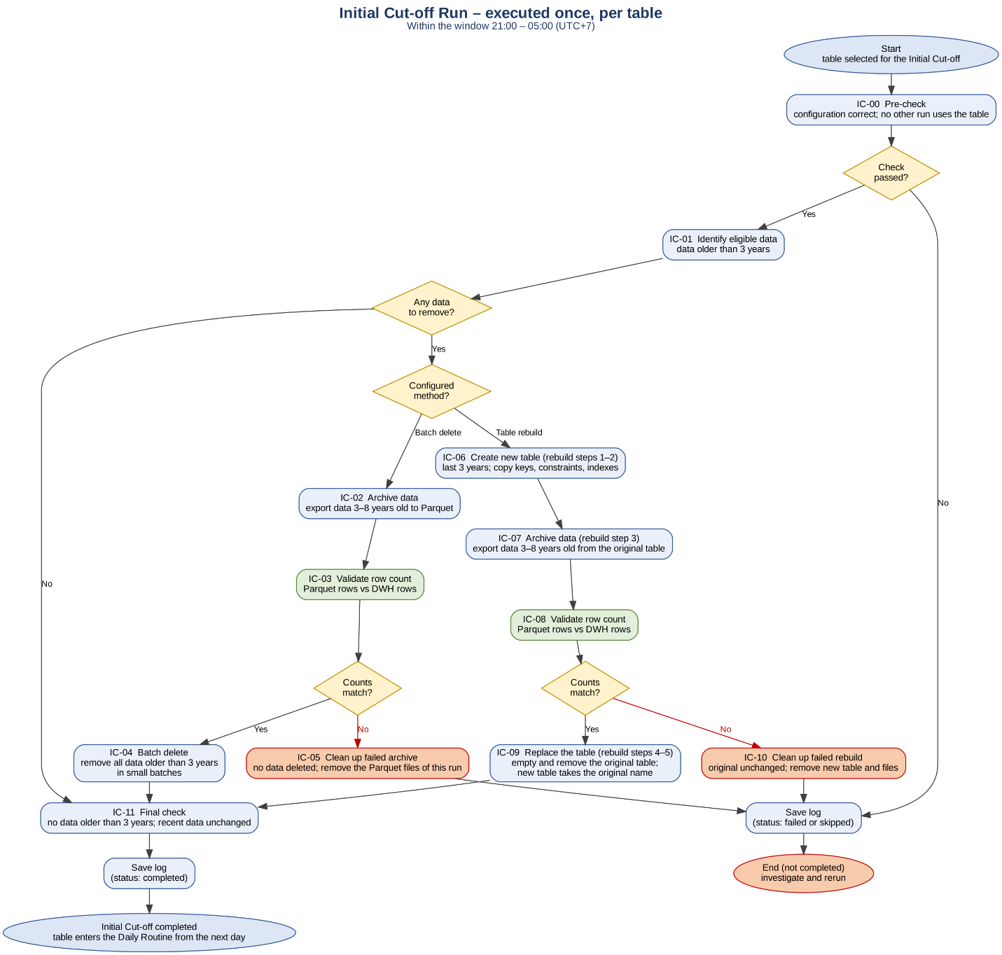
Figure 3 – Business process flow – Initial Cut-off Run
Step ID | Activity | Description
IC-00 | Pre-check | Check that the table configuration (retention period, archive path, method) is correct and that no other run is using the table.
IC-01 | Identify eligible data | Find data older than 3 years based on the business date column.
IC-02 | Archive data (batch delete) | Export data 3 to 8 years old to Parquet files in Azure Blob Storage. Data older than 8 years is not archived.
IC-03 | Validate row count (batch delete) | Compare the number of rows in the Parquet files with the number of rows counted in the DWH.
IC-04 | Batch delete | Remove all data older than 3 years from the DWH table in small batches.
IC-05 | Clean up failed archive | No data is deleted from the DWH. Remove the Parquet files created in this run.
IC-06 | Create new table (table rebuild) | Create a new table containing only the last 3 years of data and copy keys, constraints and indexes from the original table.
IC-07 | Archive data (table rebuild) | Export data 3 to 8 years old from the original table to Parquet files in Azure Blob Storage.
IC-08 | Validate row count (table rebuild) | Compare the Parquet row count with the DWH row count.
IC-09 | Replace the table (table rebuild) | Empty and remove the original table; the new table takes the original table name.
IC-10 | Clean up failed rebuild | The original table remains unchanged. Remove the new table and the Parquet files of this run.
IC-11 | Final check | Confirm that no data older than 3 years remains and that recent data (last 3 years) is unchanged.
Table 6 – Initial Cut-off Run steps
If a check, export or validation fails, no data is deleted and the archive files of the run are removed. If the window ends during the batch delete, the remaining rows are deleted in the next window. A failed table rebuild leaves the original table unchanged.

5.3 Daily Routine
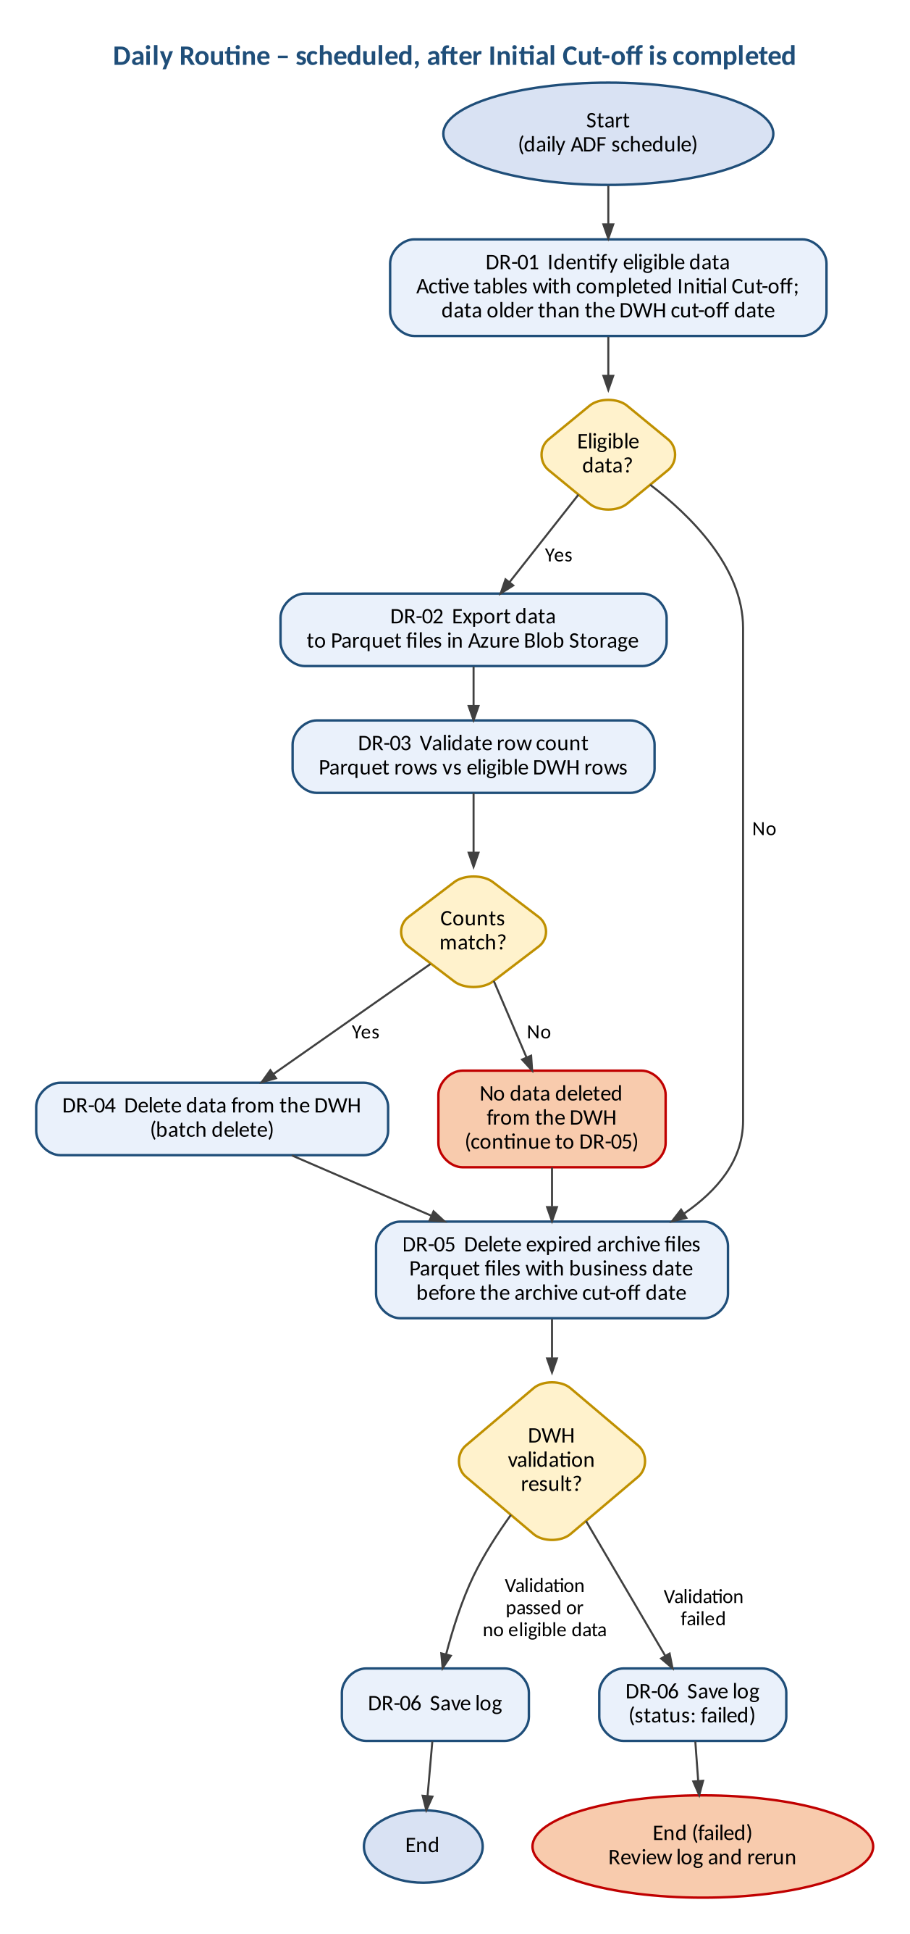
Figure 4 – Business process flow – Daily Routine
Step | Activity | Description
DR-01 | Identify eligible data | Read the active tables whose Initial Cut-off Run was completed before the run date and identify data older than the DWH cut-off date. Unfinished deletion from an earlier run is completed first. If there is no eligible data, steps DR-02 to DR-04 are skipped.
DR-02 | Export data | Export the eligible data to Parquet files in Azure Blob Storage, one file per business date.
DR-03 | Validate row count | Compare the number of rows in the Parquet files with the number of eligible rows in the DWH. If the counts do not match, no data is deleted, the Parquet files of this run are removed, the failure is logged, and the process continues with DR-05.
DR-04 | Delete data from the DWH | Only after DR-03 succeeds: delete the exported data from the DWH using batch delete.
DR-05 | Delete expired archive files | Delete archive files with a business date before the archive cut-off date. This step also runs when validation fails or there is no eligible data.
DR-06 | Save log | Record the execution result in the log tables and delete log records older than the log retention period.
Table 7 – Daily Routine steps

6. Business Rules
ID | Rule
BR-01 | The DWH retains data with a business date within the last three years. The period is configurable.
BR-02 | Total retention is eight years from the business date: the most recent three years in the DWH and the following five years as Parquet files in Azure Blob Storage. Both periods are configurable per table; the total is their sum.
BR-03 | DWH cut-off date = run date − DWH retention period. Archive cut-off date = run date − total retention period.
BR-04 | The run date is the calendar date in UTC+7 when the run starts. It is fixed for the whole run.
BR-05 | Retention is based on the business date in the retention column. Only the date part is used; the time part is ignored.
BR-06 | The retention column must be of type date, datetime, datetime2 or smalldatetime and must not contain NULL values.
BR-07 | Retention is applied as a rolling window that is recalculated on every daily run.
BR-08 | Data is removed from the DWH only after the archive has been validated successfully, that is, the row count of the Parquet files matches the row count in the DWH. During the Initial Cut-off Run this also applies to expired data: no data is removed until validation of the archived data succeeds.
BR-09 | During the Initial Cut-off Run, data with a business date before the archive cut-off date is deleted from the DWH without archiving.
BR-10 | Table rebuild is used only for the Initial Cut-off Run. The Daily Routine always uses batch delete.
BR-11 | Default Initial Cut-off Run method: small and medium tables use batch delete; large tables use table rebuild. Size limits and exceptions are set in the technical assessment and recorded per table in the configuration table.
BR-12 | The Initial Cut-off Run is executed once for each in-scope table. During the initial implementation it is executed for all in-scope tables, and the Daily Routine starts on the day after it has been completed for all of them. A table added to the configuration table later goes through its own Initial Cut-off Run and is included in the Daily Routine from the day after that run is completed.
BR-13 | The tables and their retention columns are taken from the configuration table. The process does not detect columns automatically.
BR-14 | Parquet files with a business date before the archive cut-off date are deleted by the Daily Routine, including when row-count validation of the DWH data fails.
BR-15 | Execution results are recorded in log tables, which are the basis for operational monitoring and troubleshooting. No alert or notification is sent.
BR-16 | The Initial Cut-off Run starts with small and medium tables. Large tables follow once the downtime has been determined.
BR-17 | The Initial Cut-off Run is executed within the window 09:00 PM to 05:00 AM (UTC+7), scheduled together with the ETL Owner, and must not disrupt ETL or reporting SLAs. The duration of each run is confirmed through performance testing.
BR-18 | The Daily Routine starts every day at 09:00 PM (UTC+7).
BR-19 | ETL must not write to a table while it is being rebuilt.
BR-20 | Log records are kept for three years by default, configurable per table. Older log records are deleted by the Daily Routine.
Table 8 – Business rules

7. Business Requirements

7.1 Functional Requirements
ID | Requirement
BRQ-01 | The project shall review and analyse the business and technical requirements for data retention.
BRQ-02 | The project shall analyse DWH tables to support the identification of in-scope tables and their business date columns. Customer users enter the final list in the configuration table.
BRQ-03 | The solution shall provide a central configuration table in schema ret of the DWH database with one row per table under retention.
BRQ-04 | Tables shall be added to, changed in, or removed from the retention process by updating the configuration table, without changing the pipelines.
BRQ-05 | The solution shall provide an Initial Cut-off Run that is executed once for each table.
BRQ-06 | The solution shall export data in the Archived segment to Parquet files in the Azure Blob Storage container dwh-archive, with one folder per year of the business date, one folder per table, and one file per table and business date.
BRQ-07 | Before deleting archived data from the DWH, the solution shall validate that the row count in the Parquet files equals the row count in the DWH, and shall not delete data if the counts differ.
BRQ-08 | The solution shall delete DWH data in batches of 10,000 rows with a pause of 3 seconds between batches. These values may be adjusted based on performance monitoring.
BRQ-09 | The solution shall support table rebuild as a method for the Initial Cut-off Run. The rebuilt table shall replace the original table under the original name with the same table definition; the original table is emptied and removed.
BRQ-10 | The solution shall provide a Daily Routine that is executed automatically by an ADF schedule every day at 09:00 PM (UTC+7).
BRQ-11 | The Daily Routine shall delete Parquet files with a business date before the archive cut-off date.
BRQ-12 | The solution shall record each execution in log tables in schema ret of the DWH database.
BRQ-13 | Operational monitoring and troubleshooting shall use read-only monitoring views over the log tables, showing execution status, start and end time, records processed and error details. No alert is sent.
BRQ-14 | The retention logic in the DWH shall be implemented through stored procedures and scripts in schema ret of the DWH database.
BRQ-15 | The project shall deliver documentation covering design, configuration, setup, and operational guidance.
BRQ-16 | The project shall deliver knowledge transfer sessions to the operations team.
BRQ-17 | The project shall provide hypercare support after deployment until 31 March 2027 (date under confirmation).
BRQ-18 | The solution shall keep log records for a configurable number of years per table (default three) and delete older log records automatically.
BRQ-19 | Before processing a table, the solution shall check that its configuration is complete and correct. A table that fails the check is not processed and the failure is logged.
BRQ-20 | After a failure, the solution shall remove the archive files written by the failed run and allow a rerun that completes the work without data loss and without duplicate archive files.
BRQ-21 | The solution shall prevent two runs from processing the same table at the same time.
BRQ-22 | The Initial Cut-off Run shall not start new work after the end of its execution window and shall continue in the next window.
BRQ-23 | The solution shall keep an Initial Cut-off status for each table and include a table in the Daily Routine only from the day after its Initial Cut-off Run is completed.
Table 9 – Functional requirements

7.2 Non-Functional Requirements
ID | Requirement
NFR-01 | Deletion shall be performed incrementally in batches, avoiding long-running transactions, to minimise locking and impact on ETL and reporting processes.
NFR-02 | Retention periods shall be configurable without changing the pipelines.
NFR-03 | The Daily Routine shall run without manual intervention.
NFR-04 | ETL duration: ETL execution time shall not exceed the agreed baseline by more than 10%.
NFR-05 | ETL completion: all critical ETL jobs shall complete within their agreed processing windows and SLAs.
NFR-06 | Reporting performance: report response time shall not degrade by more than 10% from the agreed baseline.
NFR-07 | Reporting availability: archive and cut-off activities shall cause no unplanned reporting downtime.
NFR-08 | Data integrity: the number of rows written to Parquet shall equal the number of rows deleted for the archived range, with no unexplained data loss or inconsistency.
NFR-09 | Security: access follows least privilege. ADF uses its managed identity; Customer users change only the configuration; the operations team has read-only access to the logs. No credentials are stored in documents, pipelines or scripts. Data is encrypted in transit and at rest.
NFR-10 | Auditability: changes to the configuration are recorded with user and time, and manual runs record the operator.
NFR-11 | Segregation of duties: approval and execution of irreversible steps (Initial Cut-off Run, table rebuild) are done by different persons.
Table 10 – Non-functional requirements

7.3 Configuration Table
The configuration table shall contain at least the following attributes for each table. The physical design is defined in the FSD.
Attribute | Description | Example
Schema name | Schema of the table | bos
Table name | Table under retention | JTI_SD_SalesReport
Retention column | Business date column; date or datetime type; no NULL values | dtmDate
DWH retention (years) | Years kept in the DWH | 3
Archive retention (years) | Years kept as Parquet files after the DWH period; total retention is DWH plus archive years | 5 (total 8)
Log retention (years) | Years the log records of the table are kept | 3
Blob path | Archive folder and file prefix of the table: <schema>.<table> in lower case | bos.jti_sd_salesreport
Size category | Small, medium or large | Medium
Initial Cut-off Run method | Batch delete or table rebuild | Batch delete
Active flag | Indicates whether the table is processed | Active
Table 11 – Configuration table attributes

7.4 Execution Log
For each table and each execution, the log shall record at least: process type, run date, DWH cut-off date, archive cut-off date, number of eligible rows, rows exported, rows deleted from the DWH, archive files deleted, status, start and end time, and error details where applicable. For each archive file, the business date, file name, row count and run are recorded. Log records are kept for three years by default.

8. Assumptions, Constraints and Dependencies

8.1 Assumptions
ID | Assumption
A-01 | The retention periods (three years in the DWH, five years in Azure Blob Storage, eight years in total) are agreed by the business.
A-02 | The required database and storage access will be provided.
A-03 | Back-dated transactions do not occur.
A-04 | The retention columns of in-scope tables contain no NULL values.
A-05 | Daily database backups remain in place.
A-06 | Business dates are stored as UTC+7 local dates.
A-07 | In-scope tables can be read while ETL loads recent data.
Table 12 – Assumptions

8.2 Constraints
ID | Constraint
C-01 | The DWH platform is Azure SQL Database; server time is UTC and cross-database queries are not supported.
C-02 | Archive files are in Parquet format in Azure Blob Storage.
C-03 | All dates are evaluated in UTC+7.
C-04 | No changes to source systems, no major schema redesign, and no partitioning of DWH tables.
C-05 | The configuration table, log tables, and stored procedures are created in the DWH database and are separated from the DWH tables only by the schema name ret.
C-06 | No automated alerting.
Table 13 – Constraints

9. Risks
ID | Risk | Likelihood | Impact | Mitigation
R-01 | As no alerts are sent, a failed execution is noticed only when the log is reviewed. | Medium | Medium | Include a daily log review in the operational guidance.
R-02 | Data older than eight years is deleted without archiving during the Initial Cut-off Run and can be recovered only from database backups. | Low | High | Confirm that a valid backup or restore point exists before each Initial Cut-off Run.
R-03 | Deleted data remains in database backups for the backup retention period. | High | Low | Accepted by the Customer.
R-04 | Network and infrastructure are outside the project scope; delays in their provision delay the project. | Medium | High | Agree delivery dates for network, Integration Runtime and storage at project start.
R-05 | Table rebuild may affect dependent database objects and ETL availability. | Medium | High | Rebuild large tables only within the agreed downtime, schedule with the ETL Owner, and review dependent objects before the rebuild.
R-06 | Large volumes deleted during the Initial Cut-off Run may increase transaction log usage. | Medium | High | Plan the execution with the DBA.
R-07 | An incorrect retention column in the configuration could remove data that should be kept. | Low | High | The configuration is checked before processing, and the Business / Data Owner confirms each business date column.
R-08 | Hypercare ends on a fixed date (31 March 2027, under confirmation); a later go-live shortens the hypercare period. | Medium | Medium | Track the go-live date against the hypercare end date.
R-09 | Without an agreed baseline, the ETL and reporting performance targets cannot be verified. | Medium | High | Agree the baseline before performance testing.
R-10 | The Initial Cut-off Run for a table added after the initial implementation (09:00 PM to 05:00 AM) may run at the same time as the Daily Routine for other tables (09:00 PM), increasing load on the DWH. | Medium | Medium | Include this case in performance testing and schedule each such run with the ETL Owner.
R-11 | With an eight-year total retention, the Initial Cut-off Run exports up to five years of data per table, which may not fit in the 09:00 PM to 05:00 AM window for large tables. | Medium | High | Confirm run durations through performance testing; the Initial Cut-off Run of a large table continues in the next window when needed.
R-12 | Retention processing runs in the same Azure SQL Database as the DWH workload and shares its resources. | Medium | Medium | Use batch delete and verify ETL and reporting impact in performance testing.
R-13 | ETL writes during a table rebuild would be lost when the original table is emptied. | Medium | High | Stop ETL writes during the rebuild; the rebuild stops if row counts change.
R-14 | Child tables without their own business date column (32 tables, about 165 GB) and their header tables keep growing while they are excluded from phase 1. | Medium | Medium | Decide the approach for child tables before the next phase.
Table 15 – Risks

10. Acceptance and Success Criteria

10.1 Acceptance Criteria
ID | Criterion | Requirement
AC-01 | The table analysis is delivered, and the in-scope tables and their retention columns are entered in the configuration table. | BRQ-01, BRQ-02
AC-02 | A table can be added to or removed from the retention process by updating the configuration table only. | BRQ-03, BRQ-04, NFR-02
AC-03 | After the Initial Cut-off Run on run date D, the table contains no data with a business date before D − 3 years, and all data on or after D − 3 years is unchanged. | BRQ-05, BRQ-09
AC-04 | After the Initial Cut-off Run, Azure Blob Storage contains Parquet files for the data from D − 8 years to the day before D − 3 years, and their row count equals the row count removed from the DWH for that range. | BRQ-06, BRQ-07
AC-05 | When the Parquet row count does not match the DWH row count, no data (including expired data in the Initial Cut-off Run) is deleted from the DWH and the execution is logged as failed. | BRQ-07
AC-06 | Batch delete removes no more than 10,000 rows per batch and pauses 3 seconds between batches, or the adjusted values where these have been changed based on performance monitoring. | BRQ-08, NFR-01
AC-07 | The Daily Routine starts at 09:00 PM (UTC+7) without manual intervention and, for each table whose row-count validation succeeded, leaves no data in the DWH with a business date before the DWH cut-off date. A table whose validation failed keeps its data until the next successful run. | BRQ-10, NFR-03
AC-08 | After the Daily Routine, Azure Blob Storage contains no Parquet files with a business date before the archive cut-off date, including on days when row-count validation of the DWH data fails. | BRQ-11
AC-09 | Each execution produces log records with the run date, cut-off dates, row counts, status, start and end time, and error details where applicable. | BRQ-12, BRQ-13
AC-10 | Retention logic is delivered as stored procedures and scripts, and the configuration table, log tables, and stored procedures exist in schema ret of the DWH database. | BRQ-03, BRQ-12, BRQ-14
AC-11 | The documentation is delivered and reviewed, and knowledge transfer sessions are completed. | BRQ-15, BRQ-16
AC-12 | Hypercare support is available from deployment until 31 March 2027, or the confirmed end date. | BRQ-17
AC-13 | Performance testing shows that ETL execution time and report response time remain within 10% of the agreed baseline and that critical ETL jobs complete within their processing windows and SLAs. | NFR-04 to NFR-06
AC-14 | Small and medium tables complete the Initial Cut-off Run before large tables; each Initial Cut-off Run runs within 09:00 PM to 05:00 AM (UTC+7), and large tables are rebuilt only within the determined downtime without unplanned reporting downtime. | BRQ-05, BRQ-09, NFR-07
AC-15 | The first Daily Routine runs on the day after the Initial Cut-off Run has been completed for all in-scope tables, and no Daily Routine runs before then. | BRQ-05, BRQ-10, BRQ-23
AC-16 | A table added after the initial implementation is not processed by the Daily Routine until the day after its own Initial Cut-off Run has been completed. | BRQ-04, BRQ-05, BRQ-23
AC-17 | Archive files are stored in container dwh-archive by year, table and business date, with one file per table and business date. | BRQ-06
AC-18 | Log records older than the log retention period are deleted by the Daily Routine; newer records remain. | BRQ-18
AC-19 | A table with an incorrect configuration is not processed, the failure is logged, and the other tables are processed. | BRQ-19
AC-20 | After a failed run, no archive files of that run remain, and a rerun completes the work without data loss or duplicate archive files. | BRQ-20, NFR-08
AC-21 | Two runs never process the same table at the same time. | BRQ-21
AC-22 | The Initial Cut-off Run starts no new export or delete batch after 05:00 AM (UTC+7) and continues in the next window. | BRQ-22
AC-23 | A permission review confirms least-privilege access; configuration changes are recorded with user and time; no credentials are stored in pipelines or scripts; irreversible steps are executed by a person other than the approver. | NFR-09, NFR-10, NFR-11
Table 16 – Acceptance criteria

10.2 Success Criteria
ID | Measure
SC-01 | After each Daily Routine, 100% of active tables whose validation succeeded contain no DWH data with a business date before the DWH cut-off date.
SC-02 | 100% of archived data passes row-count validation before deletion from the DWH.
SC-03 | After each Daily Routine, no Parquet file with a business date before the archive cut-off date remains in Azure Blob Storage.
SC-04 | 100% of executions are recorded in the log tables.
SC-05 | During the Initial Cut-off Run and the Daily Routine, ETL and reporting stay within the agreed performance targets.
SC-06 | Reconciliation shows no unexplained data loss or inconsistency.
Table 17 – Success criteria

